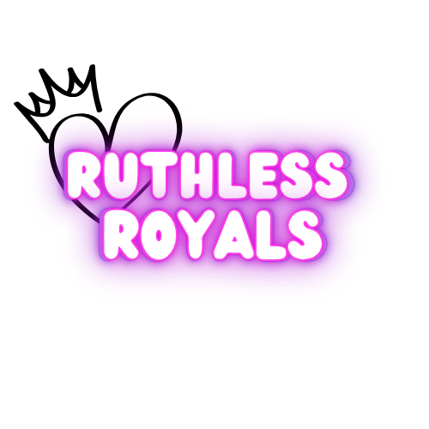
We are thrilled to have you join the Ruthless Royals, an elite and dynamic hip hop team proudly umbrellaed under GymQuest & Studio 815. As part of our team, you'll be challenged to push your limits, build your skills, and perform with the confidence and passion that define true dancers.
The Ruthless Royals are more than just a team, they are a family. Together, we will work hard, support one another, and showcase our ruthless dedication to hip hop in every move we make. Our team will compete in the Open Championship Division of Allstar Cheer and Dance, where we will represent GymQuest & Studio 815 with pride, grace, and fierce competition.
Our goal is to achieve greatness on the competition floor, and just as importantly, to foster a positive and empowering environment where every dancer can grow, thrive, and shine.
Welcome to the family, Ruthless Royals. Get ready to reign supreme!

Athlete Expectations
We expect all dancers to be committed and respectful representatives of Studio 815.
Athletes are expected to:
- Arrive on time and ready for each rehearsal
- Wear proper attire and footwear for hip hop
- Maintain a positive and coachable attitude
- Communicate student’s absences in advance (limit on excused absences)
- Show sportsmanship and respect at all events
- Keep up with outside conditioning or skills practice if assigned
Failure to meet these expectations may result in removal from performances or the team.

Parent Expectations
Parents play a vital role in the success of our team. We ask all parents to:
- Support your dancer with encouragement and accountability
- Ensure your dancer attends all practices and competitions
- Respect rehearsal times—no coaching from the sidelines
- Communicate any concerns directly with staff
- Stay up to date with emails and team announcements
- Volunteer or contribute as needed for team fundraising, props, or travel coordination
Time Commitment
- Season Length: Aug 2025 – May 2026
- Weekly Rehearsals: 1 days per week (1 hour 1 hour per session)
- Competitions: 3-4 regional competitions (Dec–April)
- 2-3 Performances a year
- Mandatory Events: All scheduled rehearsals, dress rehearsals, performances, group service projects, and competitions

Communication
Studio 815 will use Band & Email for all team communication. Please ensure contact information is up-to-date and check regularly for updates.
Clear, timely, and open communication is the foundation of a successful and smooth season. Effective communication ensures that everyone, athletes, parents, and staff are on the same page and that no one misses critical information.
For Athletes:
- Arrive prepared: Stay informed about practice schedules, events, and any changes.
- Stay on top of emails: Important announcements, reminders, and updates will be sent regularly.
For Parents:
- Check communication channels regularly: Please monitor Band or Email to stay updated on practice times, fees, events, and other important details.
- Proactive communication: If your dancer is absent or running late for practice, please notify us in advance. This helps our coaches plan effectively and ensures your dancer doesn’t miss out on important work.
- Reach out if needed: If you have concerns or questions, don’t hesitate to contact us directly. We’re here to work together for the best experience for your child.
We rely on everyone’s commitment to stay informed and engaged. When communication flows smoothly, everyone benefits, and our dancers can thrive!
Financial Commitment
We understand that competitive dance is an investment. Below is a breakdown of fees and expected costs:
Item | Estimated Cost
$70 Monthly Tuition (Aug-June) | $770
Costume | $100
Warm-Up Jacket | $75
Practice/Spirit Wear | $25
Team/Competition Fees (paid Monthly Sept- Dec) | 710
Optional Add-Ons (Backpack) | $75
Choreography Camp | $50
Music | $25
USASF Fee | 75
Optional Add Ons (Photos, team bonding, Banquet Fees)
Total (average cost) | 2,000
Note: All fees will be communicated in advance with payment deadlines.

Fundraising & Sponsorships
Fundraising efforts for the Competitive Hip Hop Program are parent-driven. Studio 815 will host fundraising opportunities at the request of parents, and when we do, we expect full participation from all families.
Fundraising helps offset team costs such as competition fees, costumes, and travel expenses. These events only succeed with everyone’s involvement, so we ask that each family commit to doing their part when opportunities arise.
If you're interested in initiating a fundraiser or helping to organize one, please reach out to the Program Director or designated parent coordinator.

Team Bonding & Spirit
At Studio 815, we believe a strong team culture leads to strong performances. In addition to practices and competitions, we’ll host three team bonding experiences per year—one each quarter—to help dancers connect, have fun, and grow as a team. These may include outings, themed practices, service projects, or spirit events.
Expect:
- 1 team bonding experience each quarter
- Spirit weeks and themed practices throughout the season
- Opportunities for leadership and community involvement
Team spirit matters both on and off the dance floor!

Competition Expectations
Our competitive season is the culmination of hard work, practice, and dedication. To ensure our team performs at its best, attendance and commitment to competitions are critical. Below are our expectations for athletes and parents regarding competitions:
Attendance at Competitions
- Mandatory Participation: All athletes are expected to attend and participate in all scheduled competitions. Competitions are a vital part of team experience, and each dancer’s role is essential to the overall performance.
- No Exceptions for Missed Practices Before Competitions: If an athlete misses a rehearsal within the two-week period prior to competition, they will not be eligible to compete at that event. This policy is in place to ensure that all dancers are fully prepared, and the performance is cohesive.
  - No Refund: Unfortunately, there will be no refunds for missed competition fees if an athlete is unable to compete due to missing critical rehearsals.
- Prompt Communication: If your dancer will be absent for any reason before a competition, please notify us as soon as possible so we can make the necessary adjustments.
Competition Day
- Arrive On Time: Athletes must arrive at least 1 hour prior to the competition start time for warm-up and check-in.
- Proper Uniform & Hair: Dancers must be in full competition attire (costume, warm-up jacket, etc.) and have their hair and makeup done as per the team guidelines.
- Team Spirit & Sportsmanship: Parents and athletes are expected to exhibit good sportsmanship and support the team, whether we win or lose.
Questions?
Contact:
Program Director: Ve’lari Dorsey.
Email: gymmanager.gymquest@gmail.com
Phone: 8156096360
Website: www.gymquest.com

